- Palestine in the 1st Century AD

  - Introduction

      - By the first century, revolt was in the air.

        - Commenting on the theo-political atmosphere of the first century, Wright says: “The hope of Israel, and of most special-interest groups within Israel, was not for post mortem disembodied bliss, but for national liberation that would fulfill the expectations aroused by the memory, and regular celebration, of the exodus, and, nearer at hand, of the Maccabaean victory. Hope focused on the coming of the kingdom of Israel’s god” (Wright, People of God, 169-70).

      - While Herod was ruling, revolts were kept at bay, due to his ruthless rule.

  - Revolts and Uprisings in the 1st Century

- Death of Herod (4 B.C.)

        - Judas and Matthias (teachers of the law; Pharisees?), who pulled down the eagle ornament that Herod placed over the temple gate. Herod punished them severely, just days before his death

        - After Herod died, a revolt took place at Passover, protesting the punishment of these two. Archelaus brutally punished the protesters.

        - While Archaelaeus went to Rome to ask to rule in Herod’s stead, a Roman procurator (Sabinus) ruled as an interim and provoked riots in Jerusalem. They were crushed by a Roman general, Varus, who came in.

        - In the same year (4 B.C.), there were two “messianic movements” led by Simon, an ex-slave of Herod who was proclaimed king by some Jews, and Anthronges, who also acted like a king and gained a brief following. Simon was killed by Rome, and Anthronges was killed by Archaeleus.

- Other first century revolts

        - In A.D. 6, a certain Judas led a massive revolt, which Josephus describes as “the most serious incident of its king between Pompey’s conquest of Palestine (63 BC) and Titus’ destruction of the Temple (AD 70)” (Wright, 172 paraphrasing Josephus).

        - Later on in the mid-40’s, a certain “brigand/bandit chief” (Tholomaus) led a revolt and was executed by Rome.

        - Around the same time, a certain Theudas claimed to be a prophet and led a popular revolt (Acts 5:36; Ant. 20.97-99) which was put down; he was executed.

        - two sons of Judas the Galilean, Jacob and Simon, were crucified by Rome for leading a revolt.

        - Sometime between AD 48-52, there was a riot at Passover where 20,000 Jews were killed.

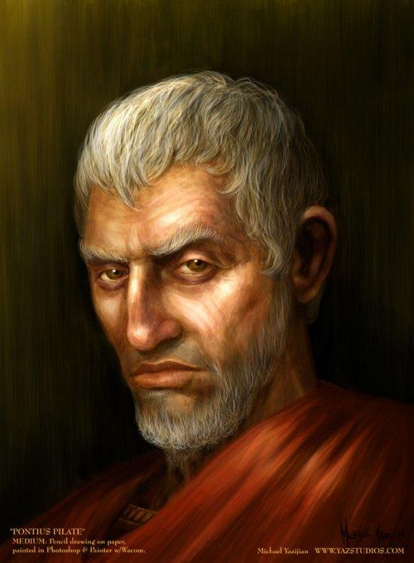
        - Rome was getting sick and tired of this, and set out to purge Palestine of all its “bandits.” The governor Felix (52-60) ended up crucifying a considerable number of them (War 2.253).

        - But the purge was only partially successful. It is around this time that the so-called Sicarii, or “dagger men,” arose and became a considerable force, leading up to the Jewish war.

      - Power Vacuum.
        - “This illustrates one main principle of Jewish revolt: the seething unrest which was normally held down tightly by repressive government and brute force could boil over when a power vacuum appeared” (Wright, 173).

      - Festivals.
        - Apart from a power vacuum, the courage and likelihood for revolt would be most prominent during the festivals: Why? Most festivals (Passover, Purim, Hanukah) celebrated God’s miraculous deliverance of the Jews from Pagan overlords!

  - Pontius Pilate (A.D. 26-36)
Figure 1 Pontius Pilate

      - We know of at least 5 incidences (not including the release of Barabbas and crucifixion of Jesus) in his 10 year rule where he oppressed the Jews and almost incited them to revolt (Wright, People of God, 174):

        - Roman standards into Jerusalem. Most generals would respect the Jews and not flaunt Roman standards by the temple, because they had images of animals, which offended the Jews. Pilate held them up high and caused a near riot.

        - Aqueduct. Used funds from the temple to help build and aqueduct; beat those who opposed his actions

        - Blood mixed with Sacrifice (Luke 13:1). Apparently, he killed some Galileans while in the temple and mixed their blood with the sacrificial offerings. He probably feared that they were staring a riot.

        - Shields in the Palace. Place a bunch of Roman shields in the palace at Jerusalem, which, according to Philo, annoyed Caesar Tiberias almost as much as it did the Jews (Philo, Leg. 299-306).

        - Slaughter at Samaria. Finally disposed after killing a bunch of people in Samaria, because he thought they were starting a revolt (they weren’t).

- During all of this, reprimanded by Rome several times; hence his uneasiness during Jesus’ trial.

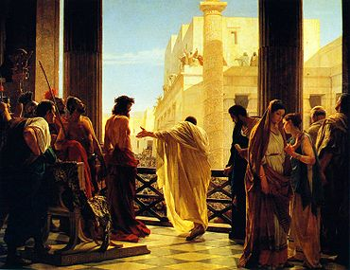

  - Emperor Caligula (AD. 37-41)

      - insisted on being worshipped as god.

      - Jews resisted; caused constant friction; he built an alter and statue of himself for the

imperial cult in Jamnia, a Jewish city in Palestine; the Jews tore it down.

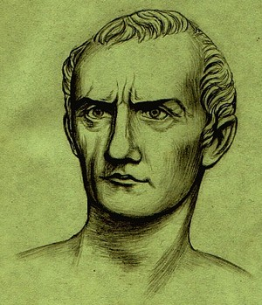
      - Caligula retaliated by having a Syrian governor (Petronius) build a statue of the emperor in the Jerusalem temple.

      - A bunch of Jews (women and children included) went and laid down with their necks exposed, saying they would rather be slaughtered than see the temple desecrated. Petronius didn’t build the statue.

      - Later, Caligula sent a letter ordering Petronius to kill himself for not building the statute, but Caligula died before the letter reached him
Figure 3 Gaius Caligula

  - Alexandrian Persecution (AD 38)

      - the governor of Egypt tried to get on Caligula’s good side by initiating a massive persecution of the (many) Jews living in Alexandria.

      - “…synagogues were burned, citizenship was revoked and they were beaten and driven from their homes. But by the end of the year the governor had been deposed and the persecution ended” (Tomasino, 308-9).

  - Herod Agrippa I (A.D. 37-44)

      - took over for Herod Phillip (in N.E. Israel).

      - in AD 41, Judea was added to his realm

      - for the most part, a good ruler; declared “king of Judea”; he was Jewish—indeed, Hasmonean! (grandson through Mariamne)

      - Very good to the Jews; so good that he initiated a persecution toward the Christians, in which James, son of Zebedee, was killed (Acts 12).

      - Reign was cut short: as he was appearing at a public gathering at Caesarea, the citizens hailed him as a god. According to both the NT and Josephus, he was struck by God for excepting this claim (Acts 12:23).

      - His son, Agrippa II, ruled over Galilee after A.D. 50 and was given responsibilities for officiated some temple affairs (see Acts 25-26).

  - Roman Governors (A.D. 44-66).

      - Felix (52-60)
        - Paul appeared before him (Acts 24)
        - “scandalous character” (Tomasino, 310); Jews frequently rebelled during his rule
        - often massacred bands of Jews whom he thought were plotting a revolt.

      - Festus (60-62)
        - decent character, but the violence was mounted and he couldn’t stop it

      - Albinus (62-65)
        - Josephus = there was no wickedness that Albinus wouldn’t entertain (Tomasino, 311); reign for two years; recalled to Rome

        - Josephus says he would catch bandits, then through bribes he would release them, making some money but putting the bandits back on the streets.

      - Florus (65-66)

        - just as greedy and shady as Albinus. Instead of trying to rid the land of its bandits, he often would be bought off through bribes and thus participated in their plunder.

        - in A.D. 66, ordered Roman soldiers to plunder the temple treasuries in broad daylight!

        - a dude mocked him by passing a basket among the crowd to collect money for “poor Florus.” He sacked the city of Jerusalem and crucified many people.

        - came back the next day and a riot broke out, but the tide shifted. The angry and fed up, the Jews kicked the Romans out of the city.

        - Florus fled to Caesarea, as the Jews took Jerusalem

        - the Revolt was on!

  - Jewish Revolt (A.D. 66—73)

      - Rome took the revolt seriously. They appointed the general Vespasian to lead the Roman counter attack, mustering 60k men.

      - He first marched on Galilee, where Josephus was the Jewish leader in charge. The Jews held strong but were defeated. Josephus was taken captive, and then became a leading figure from Rome, trying to convince the Jews to give up.

      - Two issues surrounded the revolt:

        - leadership in Jerusalem became divided. John of Gishala (a Zealot), and Simon bar-Giora (who claimed to be the Messiah), both competed for leadership.

          - (Another person, Menahem, a descendant of Judas the Galilean, was also a messianic figure from the Sicarii, but he was murdered by the rival groups.)
          - Both groups competed for leadership, but eventually, they worked together. The Jewish War became just as much a civil war as it was a revolt.

        - death of Nero; civil war in Rome. A.D. 69 would be called the year of the 4 emperors. After Nero died, each emperor that ascended to the throne was assassinated, until Vaspasian himself was chosen to be emperor.

      - After Vespasian became emperor, he appointed his son, Titus, to lead the Roman army to crush the revolt in Jerusalem.

      - After a lengthy siege, Jerusalem was taken and the temple was destroyed in on the 9th day of Ab (July-Aug) A.D. 70, the same day that Neb destroyed the first temple (586).

      - The last fortress to withstand the Romans was Masada. Fell in A.D. 73, after an 18 month siege. The Jews committed suicide (husbands killed their families, then killed themselves) so that when the Romans finally took it, they didn’t find anyone alive

        - as legend has it, 2 women and 5 children hid in cisterns and lived to tell the story of Masada.

  - Crucifixion

- Introduction.

- History.

- Scourging.

- Journey to the cross.

- Crucifixion.

- Aftermath.

  - The Aftermath of the Revolt (A.D. 74 – 135)

- with the destruction of the temple:

  - the priesthood slowly dwindle off
  - Sadducees became extinct

- But the Pharisees, who have long held control over the populous apart from the temple, remain intact (they had long emphasized that piety trumps matters related to the temple; Mark 12:33).

- Pharisees set up a school (study center) in the town of Jamnia.

- These Pharisees emerged as the sole leaders of the Jews in Palestine; they became the “Rabbis,” who produced the Mishnah (A.D. 200) and Talmud (A.D. 500).

  - Christianity and Judaism

      - Originally a sect of Judaism (Pharisee, Sadducee, Essene, Christian)

        - Pete and John going to Temple for the prayers (Acts 3:1)

        - Paul went to the synagogues (Acts 13:14, 44; 17:1-3)

        - Had Timothy circumcised (Acts 16:2-3)

        - See Acts 21:17-26

        - Did Jewish Christians forsake the Law?

          - Galatians = Gentiles
          - James

      - The Christian movement and message was not something in opposition to Judaism, but was claiming to be the true remnant of Israel. Didn’t intend to separate from Judaism.

      - But as events turned out, through Jewish rejection and various factions, it became recognized as a different religion.

      - Separate from Judaism

        - Claudius. recognized as a different religion (Claudius’ edict; Acts 18:2)

        - Nero. Nero’s persecutions (AD 64)

        - Jewish War. Christians fled Jerusalem, based on a prophecy, before the Jerusalem revolt; Jews were bitter that they didn’t take part; Jesus taught pacifism; Paul taught to submit to the government.

        - Temple. Christians even predicted the destruction of the temple and welcomed it! How offensive would this have been!!

        - Second Revolt. One more revolt from the Jews in A.D. 132. Messianic figure named Simon bar Kosiba (aka: bar Kokhbah, “son of the star”) led the revolt, but Rome crushed it in 135 and Hadrian, the Roman emperor, persecuted the Palestinian Jews heavily for several years after.

  - Summary

